

**Council for Technical Education and Vocational Training**

**Minor Project on**

**Home Library Management System (HLMS)**

**Submitted By:** **Submitted To:**

Mamata Rai Mahalaxmi Polytechnic Institute

Prasun Thapa Lamatar-9, Lalitpur

Sachin Rana Magar

Sanjok Rai

CreativeHub

**ACKNOWLEDGEMENT**

We (CreativeHub) owe a big thank you to Mr. Gagan Poudel, who provided unwavering support throughout our project, motivating and guiding us every step of the way. Additionally, our heartfelt appreciation goes to Ms. Jeena Pokharel, the course coordinator for the Diploma in IT, Mahalaxmi Polytechnic Institute, who generously shared her expertise, enabling us to enhance the project's quality. We are also grateful to our friends for their assistance whenever we encountered challenges that left us perplexed. Their support was invaluable, and we couldn't have accomplished this without them.

CreativeHub

Mamata Rai

Prasun Thapa

Sachin Rana Magar

Sanjok Rai

Diploma in Information Technology (Fifth Semester)

Mahalaxmi Polytechnic Institute

Phone 015132441, Email: [mpti2077@gmail.com](mailto:mpti2077@gmail.com)

Council for Technical Education and Vocational Training

Mahalaxmi Polytechnic Institute

Lamatar, Lalitpur.

(Bagmati Province, Nepal)

Year: Date:

Ref no:

**Letter of Approval**

This is to certify that this project prepared by **Ms. Mamata Rai, Mr. Prasun Thapa, Mr. Sachin Rana Magar, Mr. Sanjok Rai** entitled “**Home Library Management System**” in partial fulfillment of the requirements for the degree of Diploma in Information Technology has been well studied. In our opinion it is satisfactory in the scope and qualify as a project report for the required degree.

……………………………….. ………………………….

Harish Singh Thapa Jeena Pokharel

Principal Course Coordinator

Mahalaxmi Polytechnic Institute Mahalaxmi Polytechnic Institute

……………………….. .........................

Gagan Paudel Sudip Shrestha

Internal Examiner External Examiner Mahalaxmi Polytechnic Institute

**Department of Information Technology**

**Mahalaxmi Polytechnic Institute**

**Lamatar, Lalitpur, Nepal**

**Letter of Declaration**

 We hereby declare that the project work entitled **“Home Library Management System”** submitted to the Mahalaxmi Polytechnic Institute, is a record of an original work done by our group. This project work is submitted in the partial fulfillment of the requirements for the award of the degree of Diploma in Information Technology. This project has not been submitted to any other University or Institute for the award of any degree or diploma.

...................... ...................... ...................... ......................

Mamata Rai Prasun Thapa Sachin Rana Magar Sanjok Rai

**ABSTRACT**

The Home Library Management System is a web application tool created to assist individuals in effortlessly organizing their personal book collections. Its main purpose is to simplify the process of managing your home library, giving users a user-friendly and effective way to keep track of their books.With features like adding new books to your collection, keeping tabs on who has borrowed your books, updating book details, and searching for specific titles, this system is designed to make maintaining your personal library a breeze. Whether you're an avid reader or just want to keep your books in order, the Home Library Management System can help you stay organized and in control of your bookshelf.

**Abbreviation**

HLMS:- Home Library Management System

HTML:- HyperText Markup Language

CSS:- Cascading Style Sheets

PHP:- Hypertext Preprocessor (It was abbreviated as Personal Home Page)

IDE:- Integrated Development Environment

VS Code:- Visual Studio Code

ISBN:- International Standard Book Number

ER Diagram:- Entity Relationship Diagram

XAMPP:- X(cross platform), Apache, MySQL, PHP, Perl

PC:- Personal Computer

**Table of content**

Acknowledgement …………………………………………………...i

Letter of Approval……………………………………………………ii

Letter of Declaration…………………………………………………iii

Abstract……………………………………………………………….iv

Abbreviations………………………………………………………...v

1. Introduction …………………………………………………………1-3
   1. Introduction to project
   2. Problem statement
   3. Objectives
   4. Literature review
2. Requirement analysis and Feasibility analysis…………………….4-5
   1. Requirement analysis
      1. Functional requirement
      2. Hardware Requirement
      3. Software Requirement
   2. Feasibility analysis
      1. Operational feasibility
      2. Technical feasibility
      3. Economical feasibility
3. Diagrams……………………………………………………………6-9
   1. Data modeling
   2. ER diagram
   3. Flowchart
   4. Use case diagram
4. Conclusion…………………………………………………………10

Reference…………………………………………………………..11

Appendix A………………………………………………………...12-17

Appendix B…………………………………………………………18-20

# List of Figures

# Fig

* 1. Data model
  2. ER diagram
  3. Flowchart
  4. Use case diagram

# Chapter I

# INTRODUCTION

## 1.1 Introduction to project:

The "Home Library Management System" project is a user-friendly web application designed to simplify the monitoring and management of book-related data in a home library setting. Developed using a combination of HTML, CSS, and PHP, this system primarily focuses on fundamental library operations, enhancing the overall book management experience.

This web application, crafted using the versatile VS Code IDE, aims to empower users with an efficient solution for maintaining their home libraries. The system boasts a straightforward and intuitive user interface, making it incredibly user-friendly. It's engineered to cater to users of all levels of technical proficiency, ensuring that even those with limited computer skills can effortlessly navigate and utilize its features.

The core functionalities of the "Home Library Management System" include adding new books to the database, keeping track of lending and borrowing activities, and facilitating seamless book searches. These features enable users to efficiently catalog their book collections, monitor who has borrowed a book, and quickly locate specific titles within their library.

In essence, this web application represents a valuable asset for individuals seeking to maintain organized and accessible home libraries. Its simplicity, well-thought-out design, and emphasis on essential library operations make it an ideal tool for book enthusiasts and collectors who wish to enjoy a hassle-free and efficient library management experience.

## 1.2 Problem Statement:

Managing a home library can be a challenging task, especially when it comes to keeping tabs on the multitude of books in your collection, and without the aid of a management system, the endeavor becomes even more daunting.

## 1.3 Objectives:

The Basic objectives of this proposal are listed below

**a.** **Efficient Data Entry:** One of the primary objectives of the home library management system is to provide users with a streamlined and user-friendly platform for entering comprehensive data about their books. This includes not only basic details like book titles and authors but also extended information such as publication dates, genres and ISBN numbers. The system aims to make the process of cataloging books as efficient and thorough as possible.

**b.** **Effective Book Search:** Another key goal is to empower users to find books within their library swiftly and effortlessly. The system should offer a robust search functionality, allowing users to search by various criteria such as author, title or genre. The objective here is to eliminate the frustration of manual searching through shelves and enable users to locate their desired books with just a few clicks.

**c.** **Lending Status Updates:** The home library management system aims to simplify the process of tracking books that have been lent to others. Users should be able to update the system with lending information, specifying who has borrowed a particular. This objective helps users maintain accurate records of their books' lending history, ensuring books are returned in a timely manner.

**d.** **Lending Status Check:** The system should provide a convenient means for users to check the lending status of their books. This objective ensures that users can quickly ascertain whether a specific book is currently on loan or available for use within their library. It helps prevent confusion and potential issues related to misplaced or forgotten loans.

In summary, the overarching objective of a home library management system is to offer users a comprehensive and user-friendly toolset for managing their book collections. This includes entering detailed book data, facilitating efficient book searches, updating lending information, and providing real-time visibility into the lending status of each book. Ultimately, the system's aim is to enhance the organization and accessibility of a personal book library.

## 1.4 Literature review:

A thorough examination of existing literature highlights a noticeable gap in the realm of Home Library management solutions. While several applications like 'Goodreads**[1]**' offer valuable features for tracking personal reading habits, book preferences, and ongoing reads, they primarily serve as tools for readers to document their literary journeys.

Similarly, the website 'Librarika**[2]**' presents an intriguing option for creating an integrated library system; however, it is primarily tailored for professional or institutional use, rather than the specific needs of personal Home Libraries. This indicates that while there are some available resources in the broader context of library management, they might not cater adequately to the nuanced requirements of individual book enthusiasts.

Ultimately, the absence of dedicated systems designed explicitly for Home Libraries underscores the potential for the development of specialized Home Library Management Systems. Such systems could provide tailored features to assist individuals in organizing, cataloging, and efficiently managing their personal book collections, bridging the existing gap in this niche but essential area of literary management.

# Chapter II

# REQUIREMENT ANALYSIS AND FEASIBILITY ANALYSIS

## Requirement analysis

### Functional Requirement:

1. **Book Cataloging:**
   * Users should be able to add books to their library by entering details such as title, author, genre, ISBN, and publication date.
   * Users should be able to edit or delete book entries.
2. **Search and Retrieval:**
   * Users should be able to search for books within their library based on criteria like title, author and genre.
3. **Lending and Borrowing Management:**
   * Users should be able to mark books as lent to others, specifying the borrower's information.

### Hardware requirements:

* PC with processor that can handle Browser
* Monitor
* Keyboard
* Mouse
* Hard Disk

### Software requirements:

* HTML,CSS & PHP supporting web browser.
* Windows 7/8/10/11, Linux os, etc.
* XAMPP with MySQL.

## Feasibility analysis:

### Operational feasibility:

The project's operational feasibility hinges on its ability to not only be initiated but also to sustain itself effectively while adhering to the predefined operational objectives and constraints. In simpler terms, it possesses the qualities required to be executed and maintained successfully without encountering major obstacles that might impede its overall success.

This means that the project has been meticulously designed and planned to align with its established goals and operational boundaries. It has been structured in a way that accounts for the specific limitations and requirements of its intended environment. By doing so, the project minimizes the likelihood of facing significant issues or barriers that could compromise its progress or achievements.

### Technical feasibility:

The project is doable from a technical standpoint because the students who are working on it have the right skills and know-how to use the required tools and technology. Also, all the stuff we need to create the project is available and ready to use. So, we're in a good position to make this project work from a technical perspective.

### Economical feasibility:

The economic feasibility of the project is a compelling aspect, primarily because it leverages open-source and freely available software tools. This strategic choice significantly reduces the overall project cost and enhances its financial viability.

One noteworthy example is the utilization of Visual Studio Code (VS Code) as the Integrated Development Environment (IDE). VS Code's availability as a free-to-install and use platform means that there are no licensing fees or ongoing software expenses associated with the development process. This not only minimizes the initial investment but also ensures that the project remains cost-effective throughout its lifecycle.

# CHAPTER III

# DIAGRAMS

## 3.1 Data modeling:

Books

* Id
* Name
* Author
* Genre
* Edition
* Date_of_Publication
* Publisher
* ISBN
* Lent
* Lent_to

Fig 3.1: Data model

## 3.2 ER diagram:

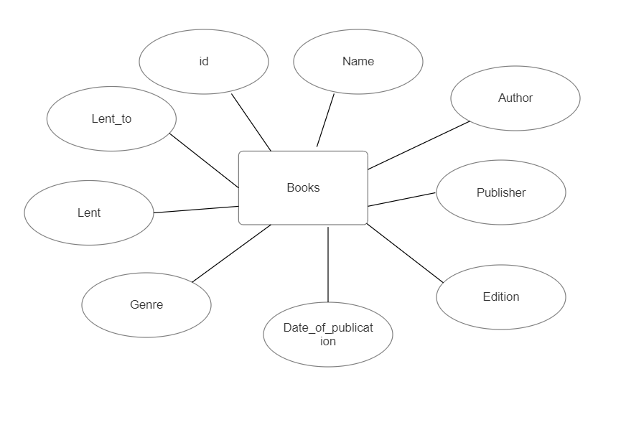

Fig 3.2: ER diagram

## 3.3 Flowchart:

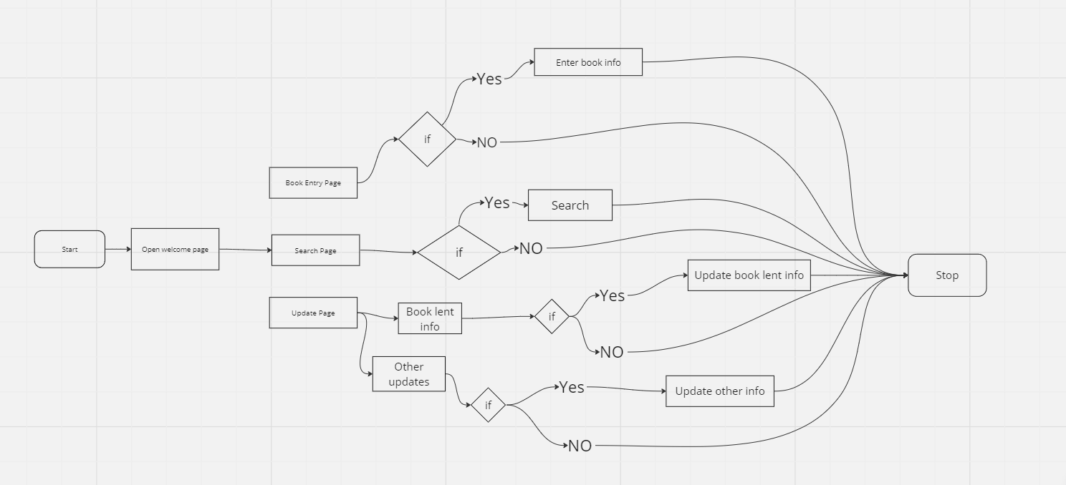

Fig 3.3: Flowchart

## 3.4 Use case diagram

user

Fig3.4 use case diagram

# CHAPTER IV

# CONCLUSION

The Home Library Management System should undergo a computerization process to enhance its efficiency. This document outlines the information needed to create a computerized library management system with the aim of improving library organization. This system is tailored to store comprehensive information about the books in the library.

The primary objective of this project is to promote effective and organized record-keeping within the library. While we are initially developing a web application, it's important to note that this project can serve as a foundation for creating a software solution with even more advanced features in the future.

# REFERENCE

1. Mike Thelwall and Kayvan Kousha - Goodreads: A Social Network Site for Book Readers, Feb 2016
2. Mayank Yuvaraj – Library automation with cloud based ILMS Librarika: case study of Central University of South Bihar

# Appendix A

## Welcome page HTML:Screenshot 2023-09-15 130414.png

## Book entry form HTML:

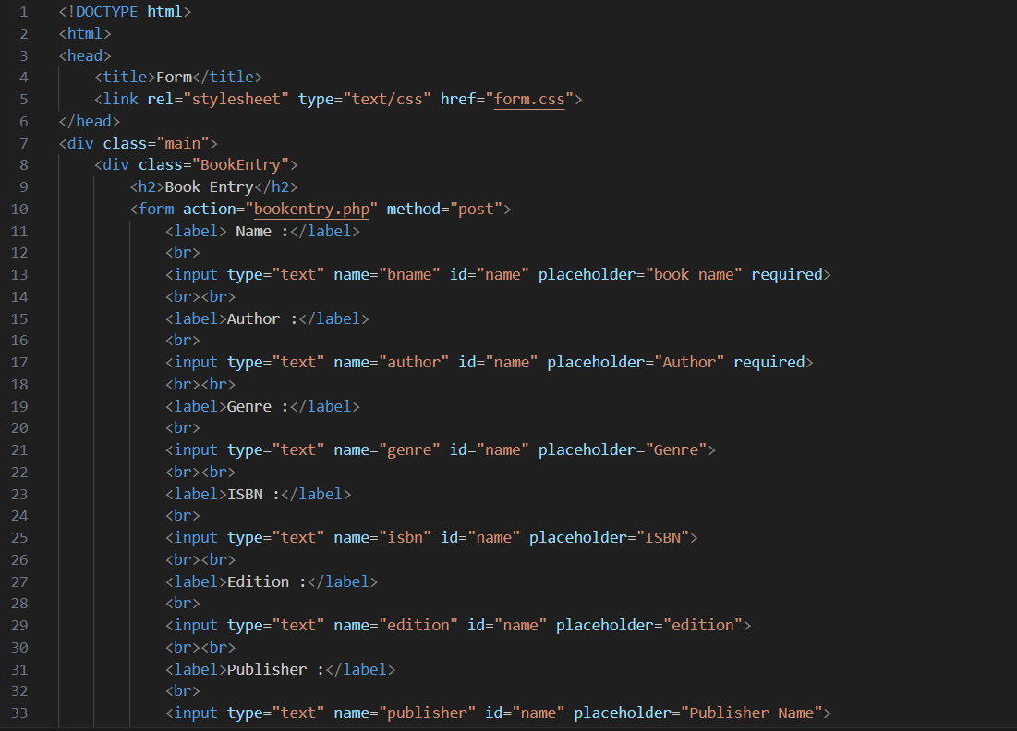

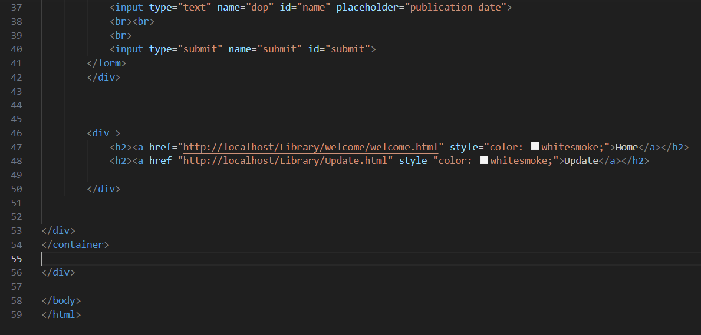

## Book entry form CSS:

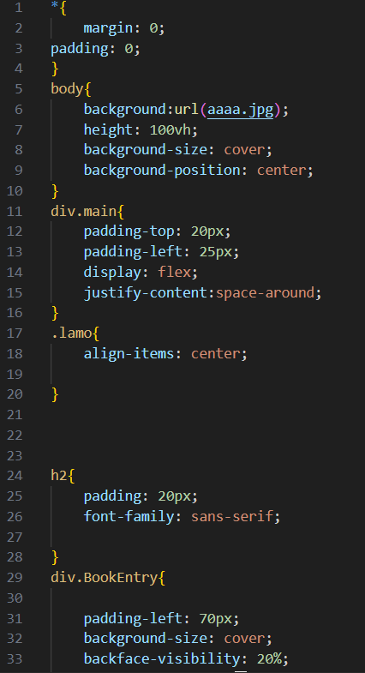

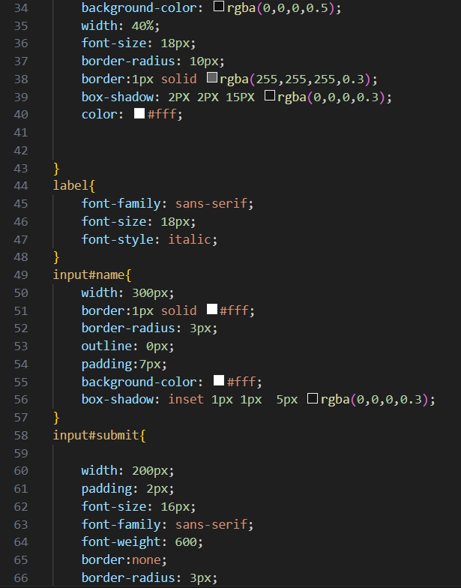

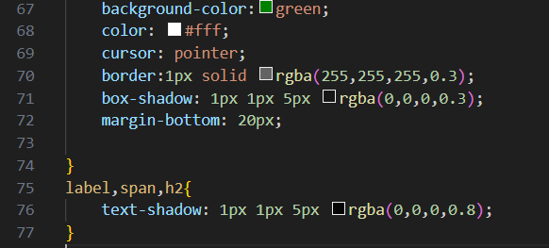

## Book entry form php:

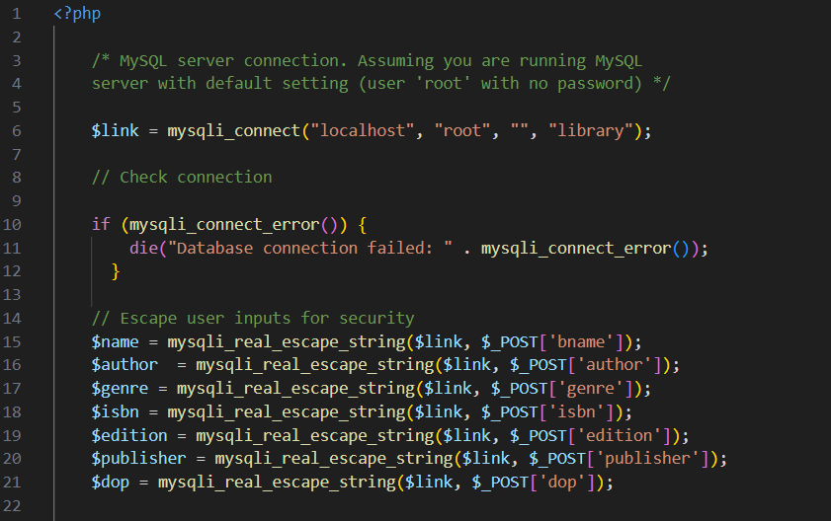

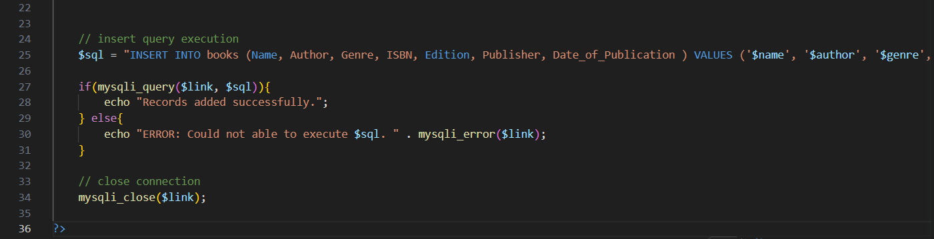

## Database:

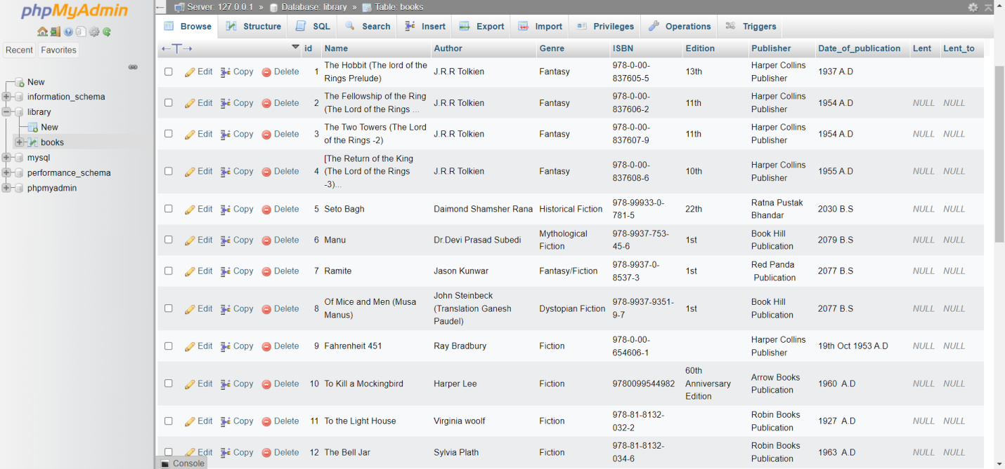

# Appendix B

## Welcome page:

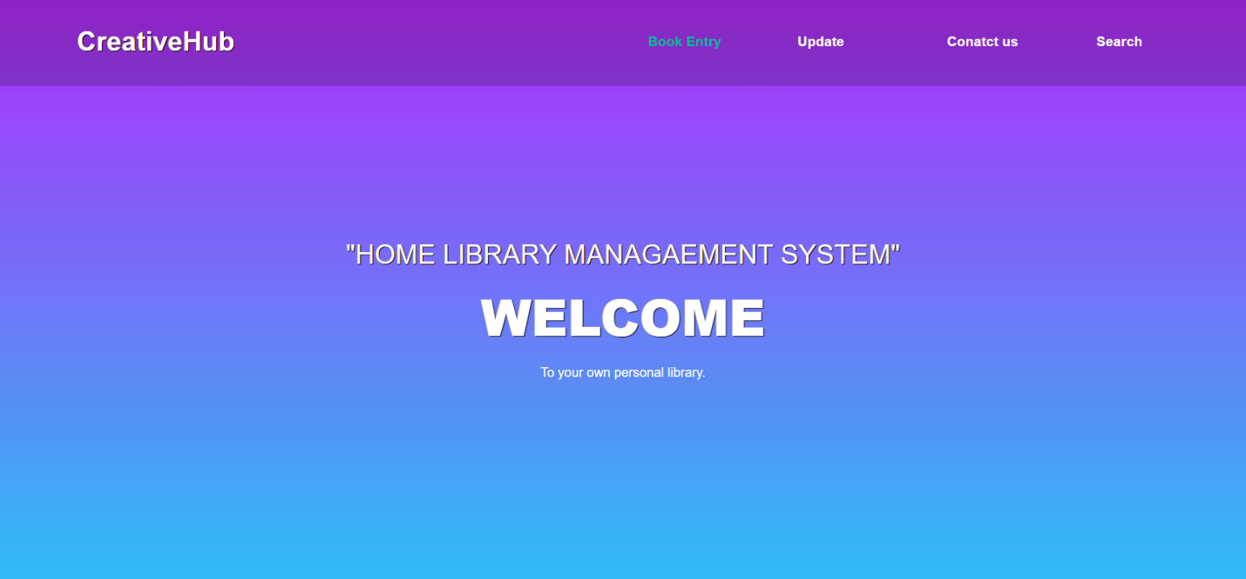

## Book entry form:

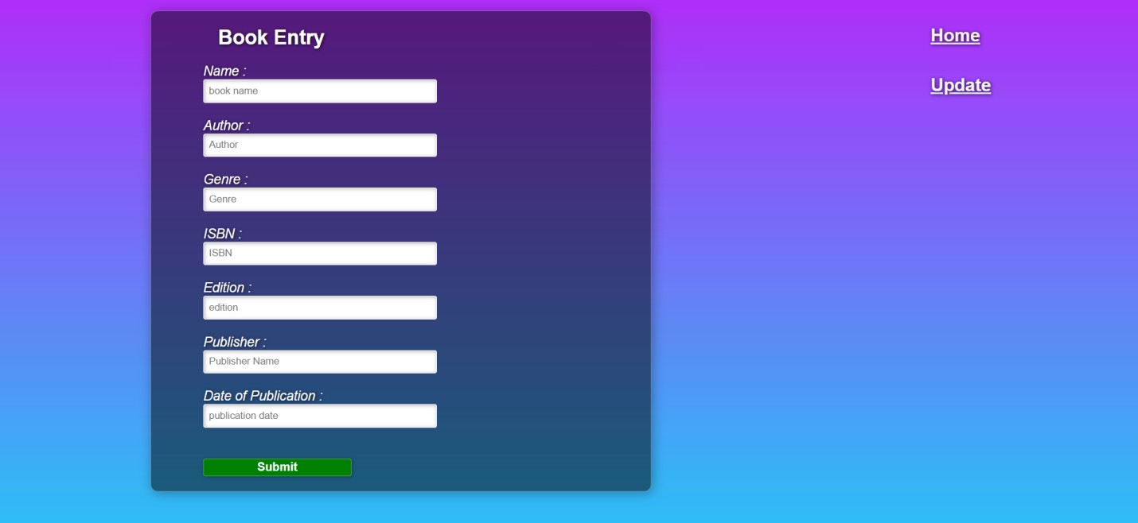

## Search page:

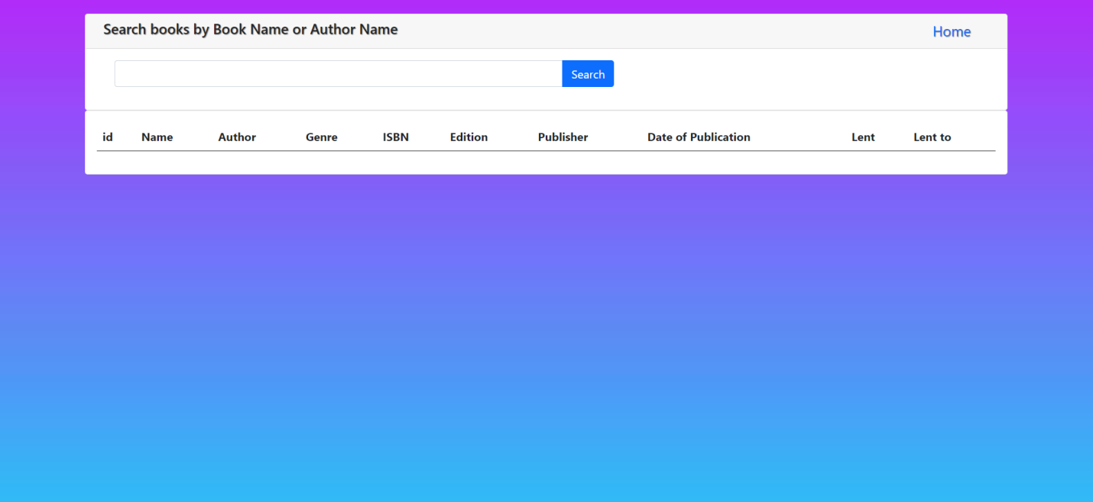

## Update page:

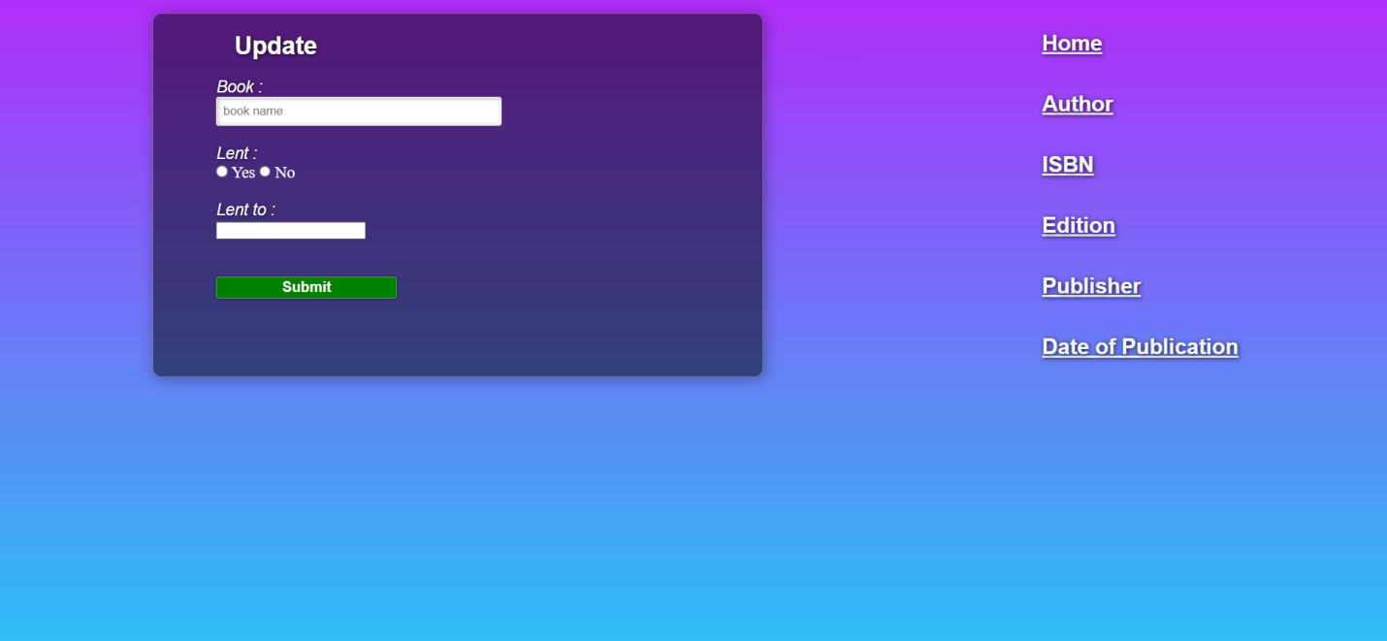

## Author update page:

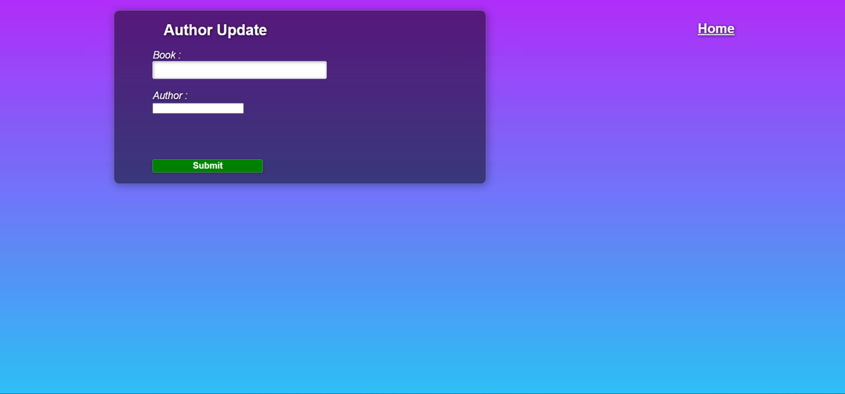

## ISBN update page:

